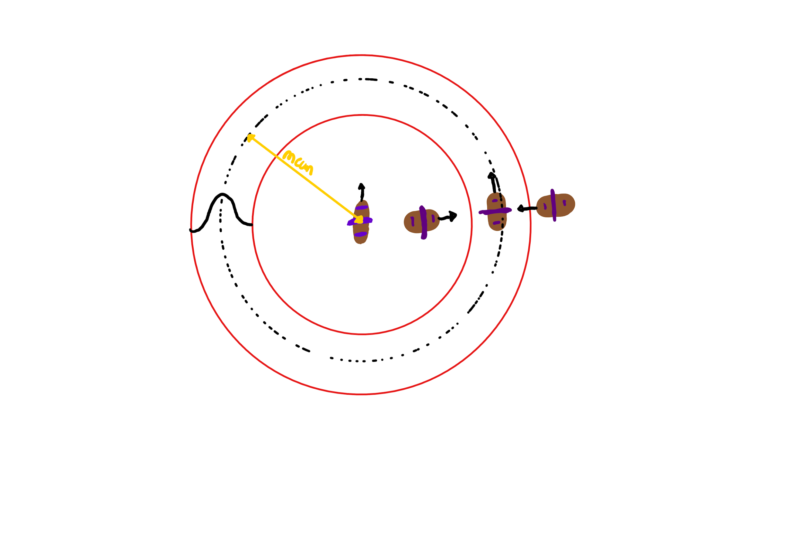

When NPCBoats are encountering players they want to be moving towards the player however they don’t want to get to close and ram the player. This is why there is a function which makes it so the NPC always try to move to the peak/max value of the function, which is 1. The reason why this is done as a normal distribution is to allow the transition to be smooth. Once the boat is at the peak value it wants to try and follow the players path so the NPC will try to turn in the direction of which the player is moving.

To make transitions smooth and for later use with the NPC encountering different objects this is done as a resultant force where the forces acting on it aren’t real forces but are how much the NPC wants to head in that direction.

Different functions can be used other than the normal distribution to create different effects/personalities to the NPC for example the mean could be changed so for ships with let's say a shotgun can want to be in closer.